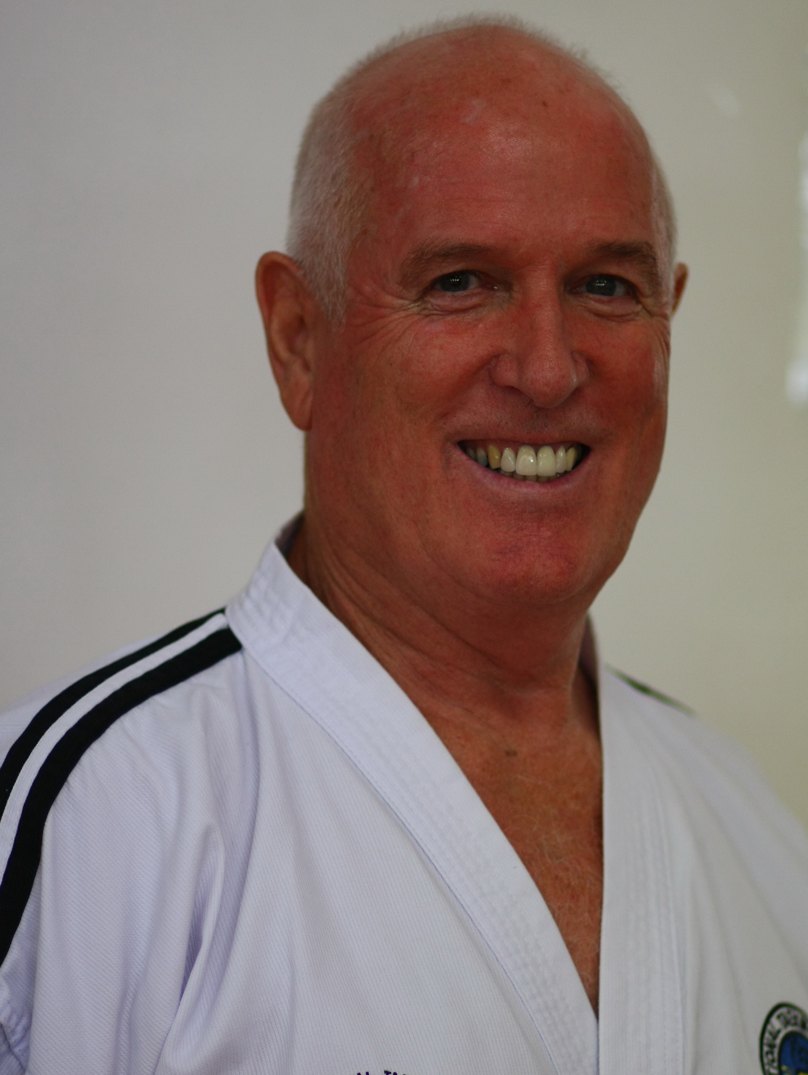Grand Master Graeme (Rocky) ROUNTHWAITE

50 years Taekwon-Do Experience Professional Instructor (9th degree)
30 years Policing Experience International Instructor/Examiner/Umpire
20 years Overseas Experience (Papua New Guinea, Australia, Thailand)
6 years Joint Residential Head, American Pacific International School, Thailand
Member of the International Taekwon-Do Federation, New Zealand
Inducted into the New Zealand Martial Arts Hall of Fame (2013)
ITFNZ Life Membership (2025)

https://www.rtrtkd.co.nz/ Partners ____________________________________________________________

TAEKWON-DO HISTORY

International Instructor/Other Courses –
Online – TKD ‘Do’ course (2022)
New Zealand (2020/2017/2013/2006/2004/1993/1990)
Australia (2023/2022/2015/2004/1999/1996/1988/1984/1982) India (2014)
Malaysia (2010/2000) Vietnam (2009)
Philippines (2005) USA (1997/1990)

International Umpire Experience
Online – Umpires Update Course (2025)
Int Umpires Course, New Zealand (2019) World Cup, Sydney, Australia (2018)
Int Umpires Course, New Zealand (2016) Int Umpires Course, New Zealand (2013)
Umpires Course, New Zealand (2011) World Championships, New Zealand (2011)
Asian Championships, Vietnam (2010) Int Umpires Course, Hong Kong (2006)
World Championships, Germany (2005) World Championships, Poland (2003)
Oceanic Championships, Canberra (2002) World Championships, Malaysia (1994)
New Zealand Championships (1989) South Pacific Championships, Fiji (1983)
International Teaching Experience 1982 – 2026
New Zealand (2011-2026) Thailand (2005-2010) Australia (1995-2005)
Papua New Guinea (1991–1995) New Zealand (1982–1991)

TKD International Tours
‘Tul’ (TKD cultural) tour of South Korea (2018) ‘Tul’ (TKD cultural) tour of South Korea (2015)
Goodwill tour Thailand (2013)
World Camp, USA (2002/2000/1993/1990/1986) World Camp, Australia (1998)
Goodwill Tour Ireland (2006) Papua New Guinea (1986)
Rarotonga (1985)

International Administrative Experience
iTKD Senior Examiner (2012-2026) Technical Advisory Group (iTKD) – (2012-2025)
Executive Officer, ITF Thailand 2005 – 2010 Secretary General, ITF Asia (2005 - 2008)
ITF Ethics Committee (2005 - 2008) Congress rep, Germany (July 2005)
Vice-President ITF Papua New Guinea (1991 – 1995) Commendation by Gen Choi, Hong Hi (1995)
Board of Directors MYITF (1988) Director – Stand & Disc, ITFNZ (1990–1991)
Director - National Championships, New Zealand (1987/1984)

General
Nominated Life Member of ITFNZ (2025)
Promoted ITF Grand Master (9th degree) 28 June 2023 – Certificate Number NZ-9-3
ITFNZ Presidents Award recipient for ‘outstanding contribution to furthering Taekwon-Do’ (2017)
Promoted ITF Master (8th degree) (India IIC – 14/6/2014)
International Harmony Course (NZ - 2017)
Inducted into the New Zealand Martial Arts Hall of Fame (2013)
Professional Instructor (2011-2023) New Zealand
Member of New Zealand Martial Arts Institute (2013-2023)
Promoted ITF Master (7th degree) (Philippines IIC - 2005)
Professional Instructor (1995-2005) Australia
Commendation by General Choi, Hong Hi (1995) – “Establishing and pioneering TKD in the highlands of Papua New Guinea” International Instructor (1991)
International Instructor (1990) International Examiner (1991) International Umpire (1991)
Justice of the Peace (Qual) course (2003) (JP Society, Qld)
Commonwealth Games Opening team member, Auckland (1990)
Television commentator for an international tournament, Wellington (1985) Recipient Pakuranga Jaycees Community Service Award (1983) Commenced tng at Stokes Valley, Wgtn Region (1976)
EDUCATION

Sunshine Coast University, Qld, Australia (U3A)
Sports and Events Marketing (1999) Anatomy & Physiology, Marketing (1998).
Australian Sports Institute (National Officiating Accreditation Scheme)
University of Auckland, New Zealand
COP Criminology (Police Commissioned Officers exam) (1983)
COP Criminal Law (Police Commissioned Officer exam) (1978)
New Zealand Police
Police Duties (Police Commissioned Officer exam) (1980)
Qualified Instructor, NZ Police College, Trentham (1975) - Criminal Law and Police Practice
New Zealand Institute of Management
Introductory subjects towards Diploma in Business Management
First Aid
NZ Red Cross ‘Save a Life’ (2024)
NZ Red Cross ‘Save a Life’ (2022)
NZ Red Cross ‘Save a Life’ (2020)
NZ Red Cross ‘Save a Life’ (2017)
NZ Red Cross ‘Save a Life’ (2015)
NZ Red Cross ‘Save a Life’ (2013)
NZ Red Cross ‘Save a Life’ (2010)
Thailand CPR update (2009)
Thailand First Aid course update (2006) CPR update (2006)
Australian Red Cross - Senior First Aid course (2004) CPR updated March 2004

Courses
Umpires Online Update Course (2025)
Instructor update course, Hastings (2025)
IIC, Perth, Australia (2023)
iTKD Masters Summit (2023)
iTKD National Camp (2023)
IIC, Australia (2022)
iTKD Instructor update course, NZ (2022)
Child Protection in play, active recreation & sport (2022)
iTKD Instructor update course, NZ (2021)
International Instructors Course, NZ (2020)
iTKD Instructor update course (Wellington) (2019)
International Umpires Course (Auckland) (2019)
iTKD master’s Summit (2018)
Harmony Course (Taekwon-Do for mature students) NZ (2017)
iTKD Master’s Summit (2017)
International Instructors Course, NZ (2017)
iTKD Instructor Update Course (2016)
iTKD Master’s Summit (2016)
International Instructor Course, Gold Coast, Australia (2015)
iTKD Instructor Update Course (2015)
iTKD Master’s Summit (2015)
iTKD Master’s Summit (2014)
iTKD Stripes 1 to 1 seminar (2013)
iTKD Instructor Course, New Zealand (2013)
iTKD Instructor Conference, New Zealand (2011)
Cultural Differences and Similarities (2009)
“Third Culture Kids at International Schools”
“Importance of International Mindedness for 21st Century Students”
Cultural Education, Thailand
Thai Language Culture and Professional Ethics for Non-Thai Teachers (2009)
Mahout course (2008/2013)
Traditional Thai massage - Basic/Advanced (2008)

Employment
2011 - 2026 Professional Taekwon-Do Instructor, New Zealand
2005 - 2010 Teacher/Residential Head, American Pacific International School, Thailand
1995 - 2005 Professional Taekwon-Do Instructor, Qld, Australia
1991 - 1995 AUSAID Police Consultant, Royal Papua New Guinea Constabulary
1988 - 1991 Officer in Charge, Wharf Police, Auckland, New Zealand
1979 - 1988 Team Policing Unit (Riot Squad), Auckland, New Zealand
1975 – 1979 Instructor, New Zealand Police College, Trentham.
1966 - 1975 New Zealand Police, Auckland, New Zealand
1965 – 1966 Police Cadet Training, Trentham, New Zealand
1964 – 1965 Hospital Orderly, Waikato Hospital, New Zealand

Personal Details
Master Graeme (Rocky) Stuart Rounthwaite (9th degree) Promotion date 28 June 2023
PO Box 986, Hastings, New Zealand, 4156
Phone +64 (0)210323289 e. rtrtkd@gmail.com
Birthplace - New Zealand Citizenship – New Zealand/Australia
Occupation – Professional Taekwon-Do Instructor

Recreational Interests
Taekwon-Do Camping Travel Diving
Genealogy 4-wheel driving Web page Thai Massage
Elephants

Countries travelled.
Myanmar (2019), South Korea*, India*, China, Vietnam*, Laos, Cambodia, Thailand*, Taiwan, Hong Kong*, Dubai*, Philippines*, New Zealand*, Australia*, Tonga, Samoa, Fiji*, Cook Islands, Nui, Vanuatu, Papua New Guinea*, Singapore, Malaysia*, Indonesia*, England*, Ireland*, Belgium*, Germany*, France*, Poland*, Holland, Canada, USA*, Guam, Hawaiian Islands*
*Denotes countries TKD practised in

Resided in New Zealand, Papua New Guinea, Australia, and Thailand.
Married - Trish Rounthwaite (5th degree) International Instructor/Examiner/Umpire (ITF)
Professional Educator, Professional Taekwon-Do Instructor
Family - Sheryl (3rd degree) Examined by TKD Founder, General Choi Hong Hi
- Mark (5th degree) International Taekwon-Do Instructor,
Professional Stunt Coordinator/Choreographer/Movie Director. Movies include:
Hellboy (2019), Charlie’s Angels (2019), Super Fly (2018), The Nice Guys (2016)
Ironman 3, The Gunman, Ek Tha Tiger, Ghost Riders, Mission Impossible,
Lord of the Rings, Alexander, King Kong, Casino Royale, The Borne Ultimatum, Indiana Jones and the Kingdom of the Crystal Skull, Green Zone, The Last Airbender, Ghost Rider 2, Iron Man 3 – more..... https://www.themoviedb.org/person/122354-markos-rounthwaite

(24 August 2026)

